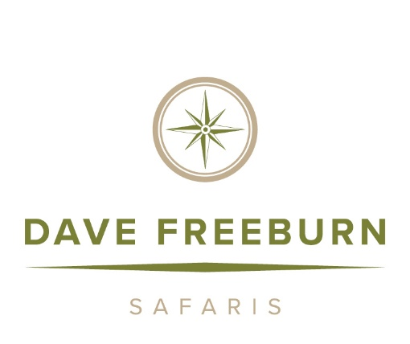

ZEBRA CULL 2026

Safari Outfitting 1 X 1 Rates Outfitting 2 x 1 Rates
Plains game $6,500 per hunter $5,500 per hunter
Observer $ 220.00 per day.

S A F A R I R A T E S I N C L U D E

- 8 Nights accommodation
- The service of qualified Professional hunter, tracker, chef, skinners, camp staff.
- Fully equipped four-wheel drive vehicle.
- Accommodation while on safari.
- Full catering including fine South African cuisine.
- Bottled water, soft drinks, local beers, and alcohol.
- Daily laundry service except Sundays
- Transport by road from O.R International airport.
- Field prep of all trophies hunted with DFS.

S A F A R I R A T E S D O N O T I N C L U D E
- Any personal expenses.
- Accommodation before and after contracted safari dates.
- Firearm Import permit approximately $160 per rifle.
- Trophy fees not included in any package / specials.
- Gratuities to staff and Professional hunter (cash only)
- Cost of transportation to places beyond our concessions.
- Taxidermy. Dipping and shipping of trophies to final destination.
- CITES permits, additional hunting permits.

B O O K I N G C O N D I T I O N S
- A deposit of 50% of packages required to confirm booking and dates including value added tax 15 %
- Balance of daily rate is due 60 days before commencement of safari.
- Prices are subject to change without prior notice due to fluctuation in exchange rates.
- 15% VAT will be added to any animals wounded or lost.
- Trophy fees are payable at the end of the safari. (speak to your PH about payment options)

